**AWARENESS PROGRAMME CONDUCTED ON 15TH Dec, 2019 about Women problems**

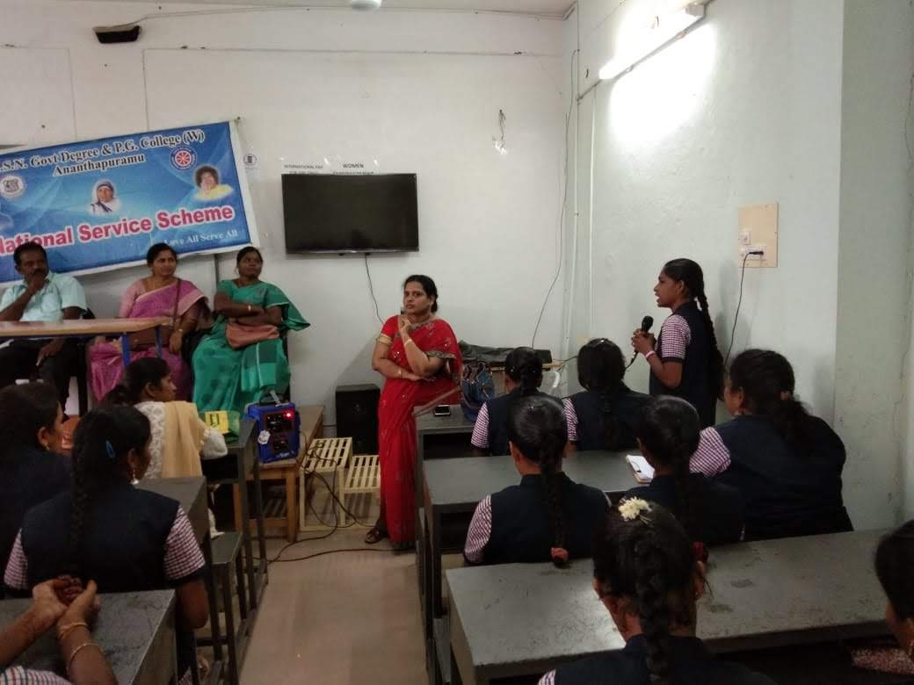

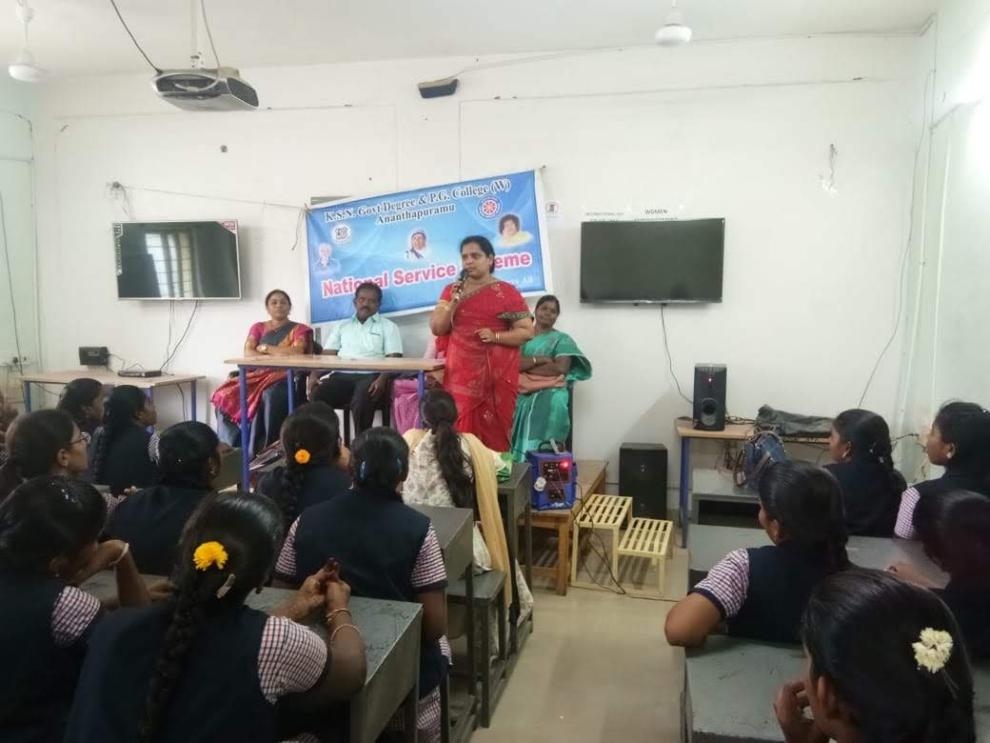

Participated in Janmabhumi Programme at Gram Panchayat Office, Ananthapuramu Rural on 3/1/19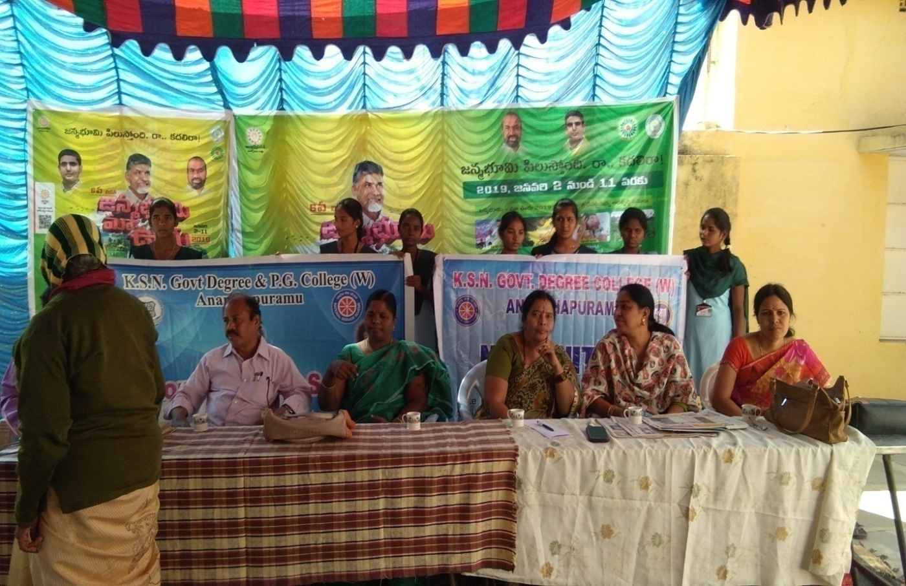

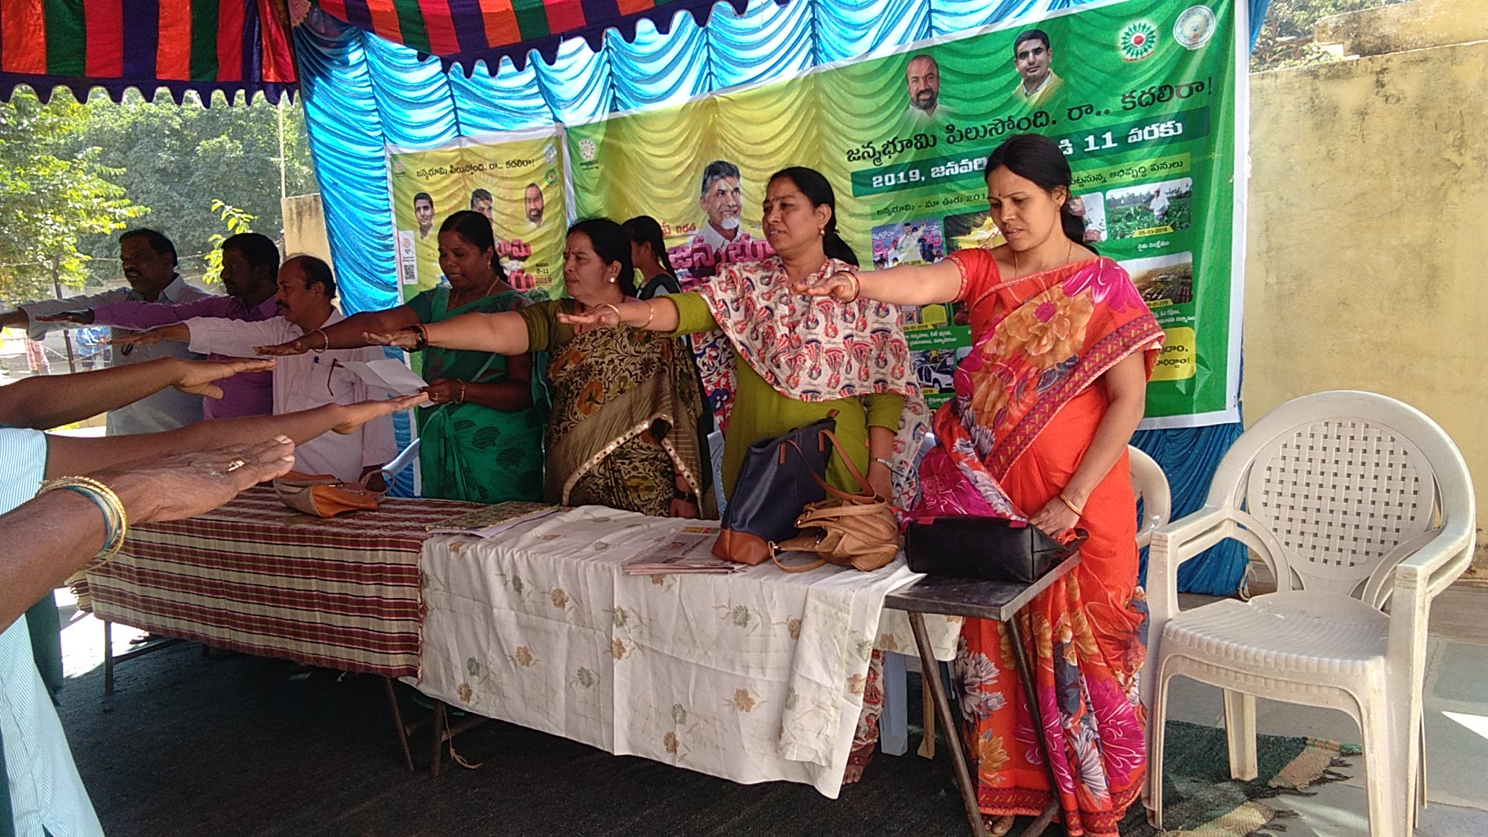

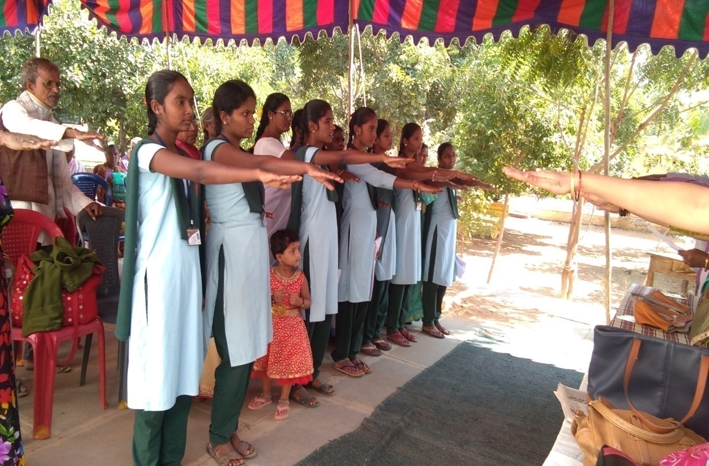

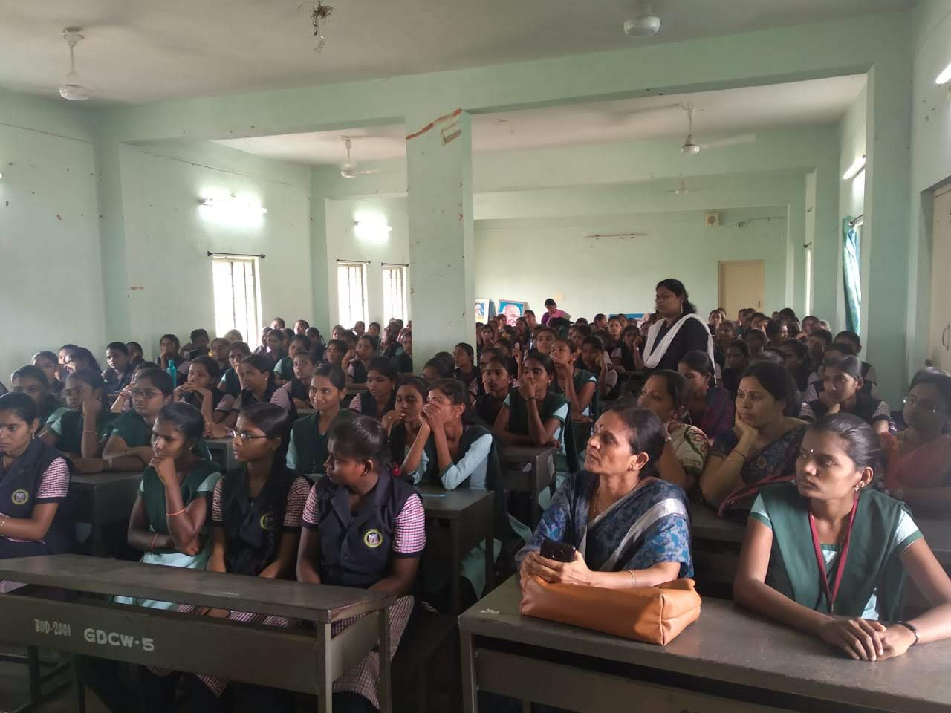

**Celebration of National Voters’ Day on 25th Jan. 2019**

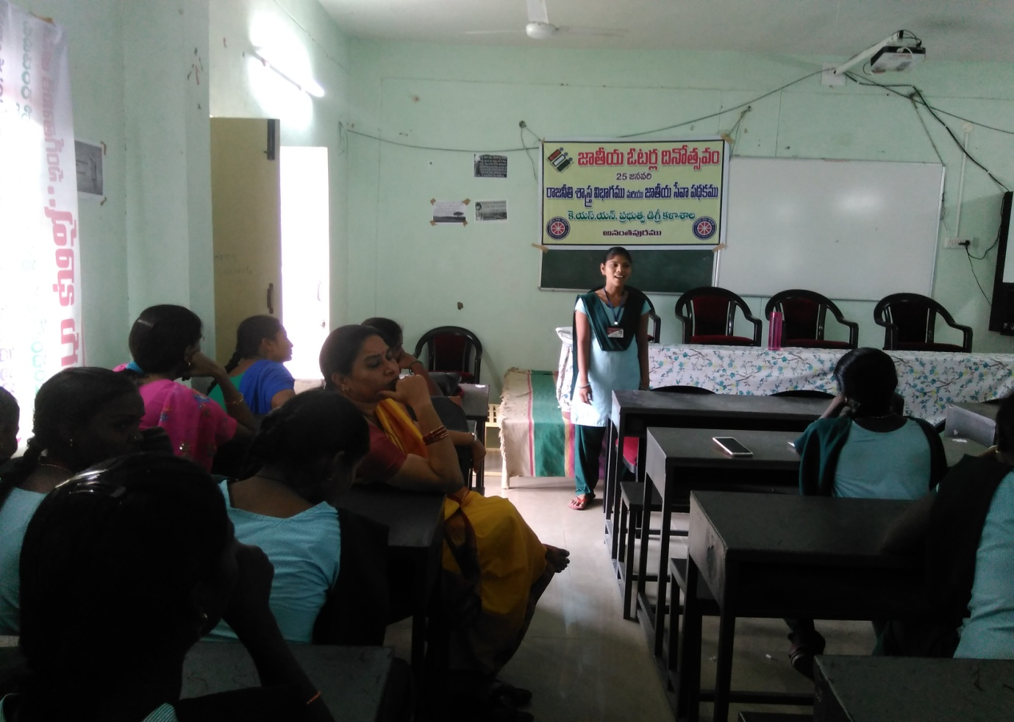

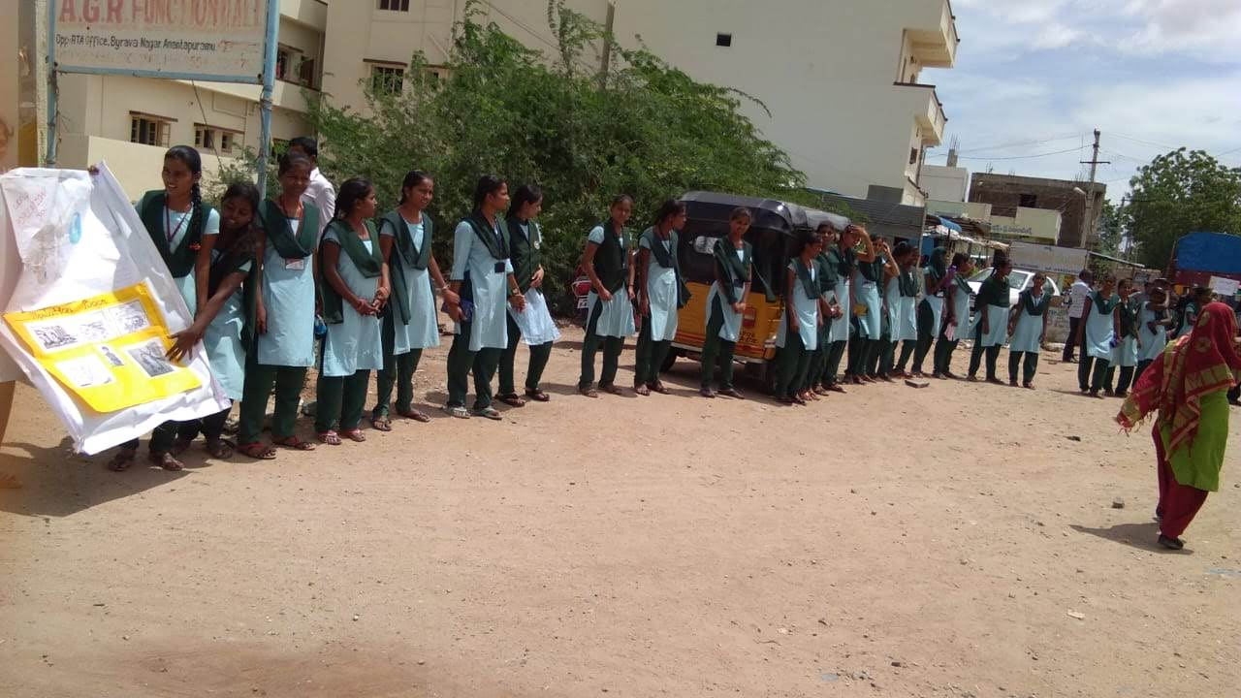

**Plantation Programme by the Principal and students on 26.01.2019**

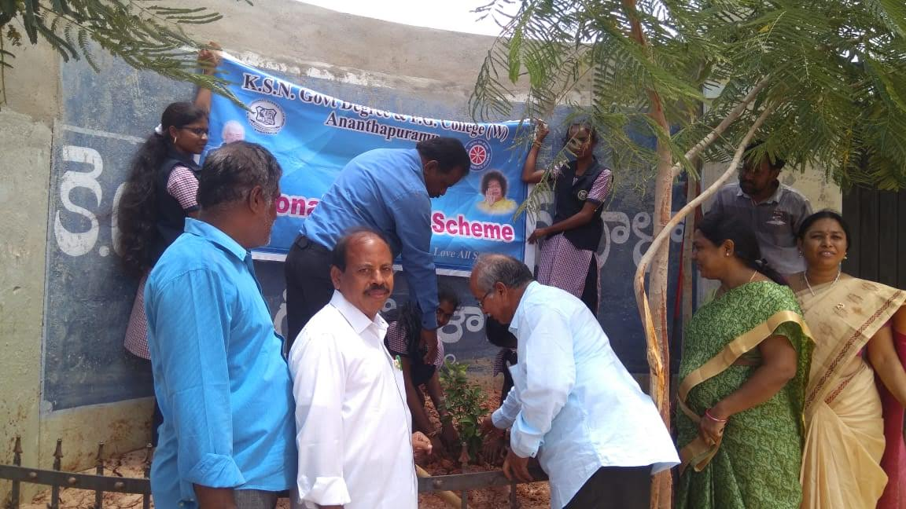

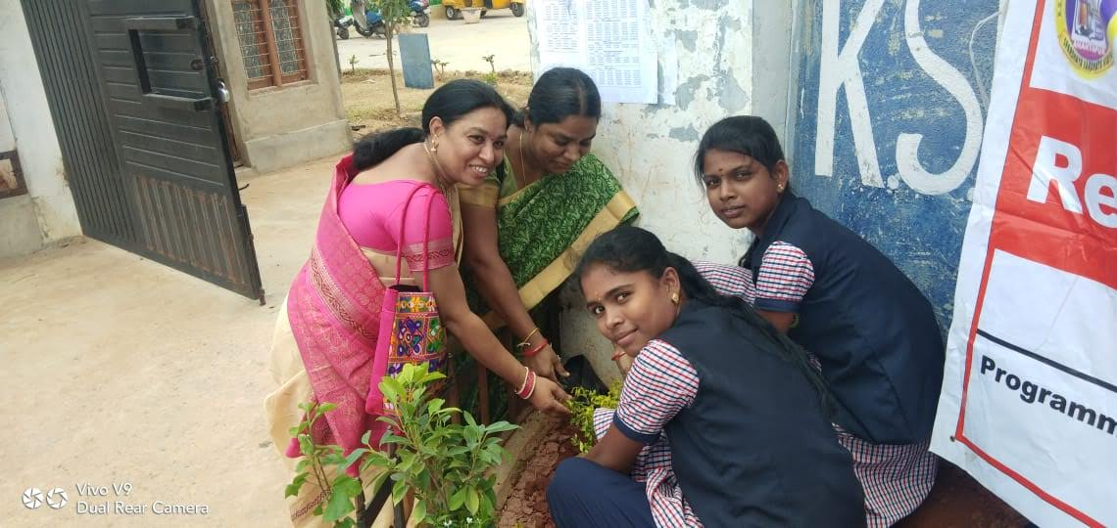

**Conducted Medical Camp on 28.01.2019**

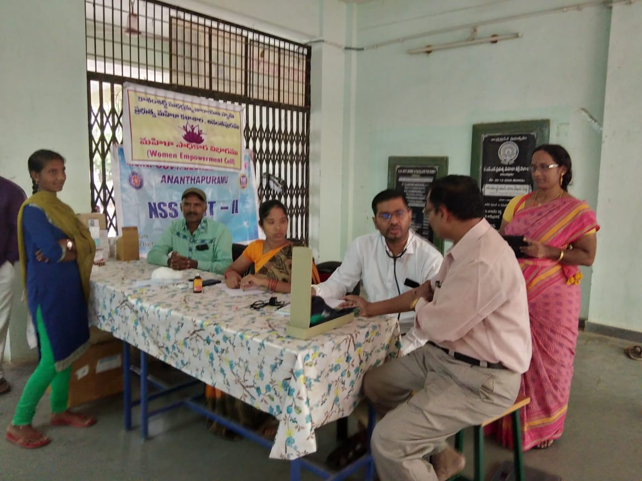

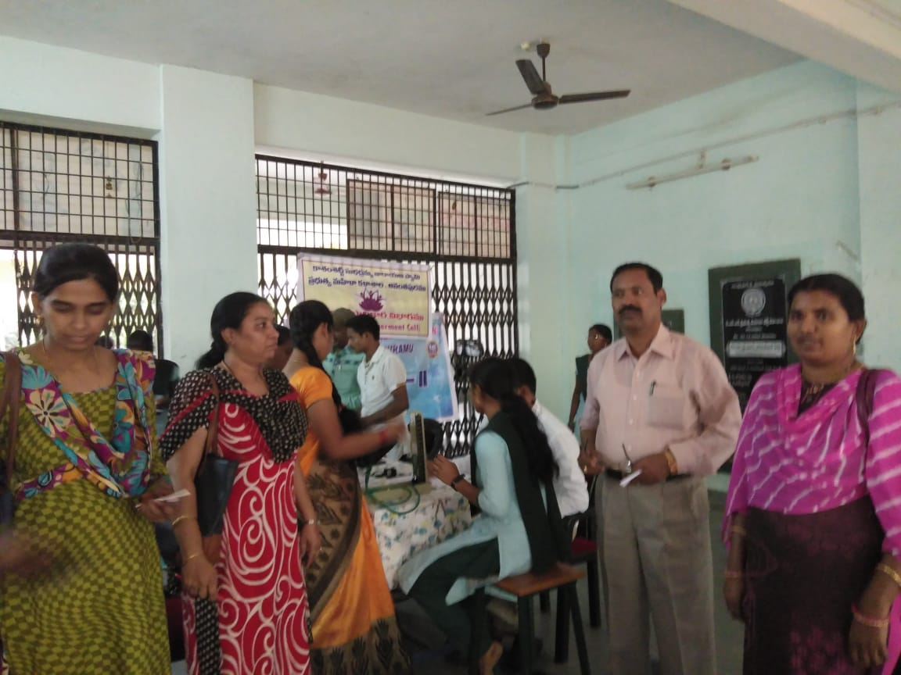

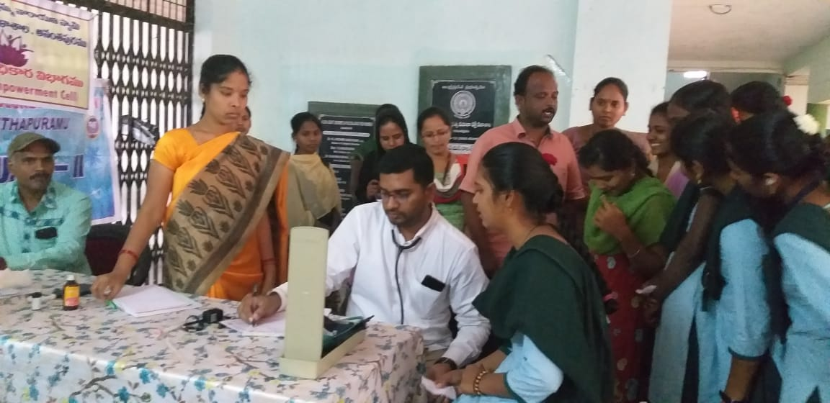

**Celebration of Subhash Chandra Bose Jayanti on 29.1.2019**

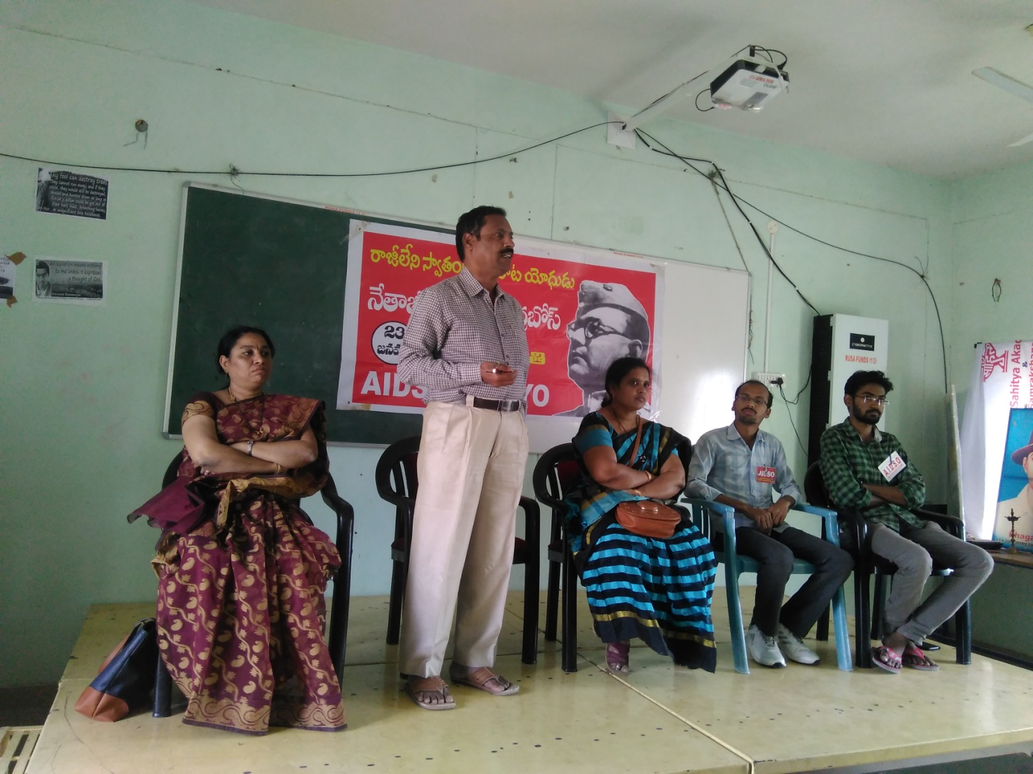

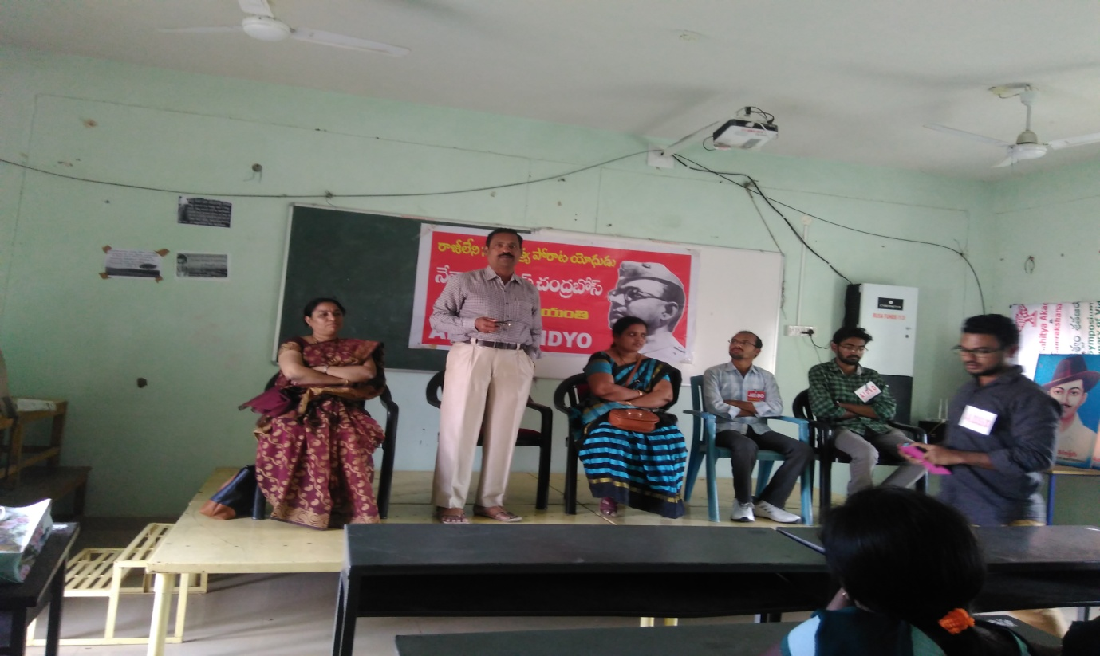

**SWATCH BHARAT IN THE CAMPUS ON 14TH Feb, 2019**

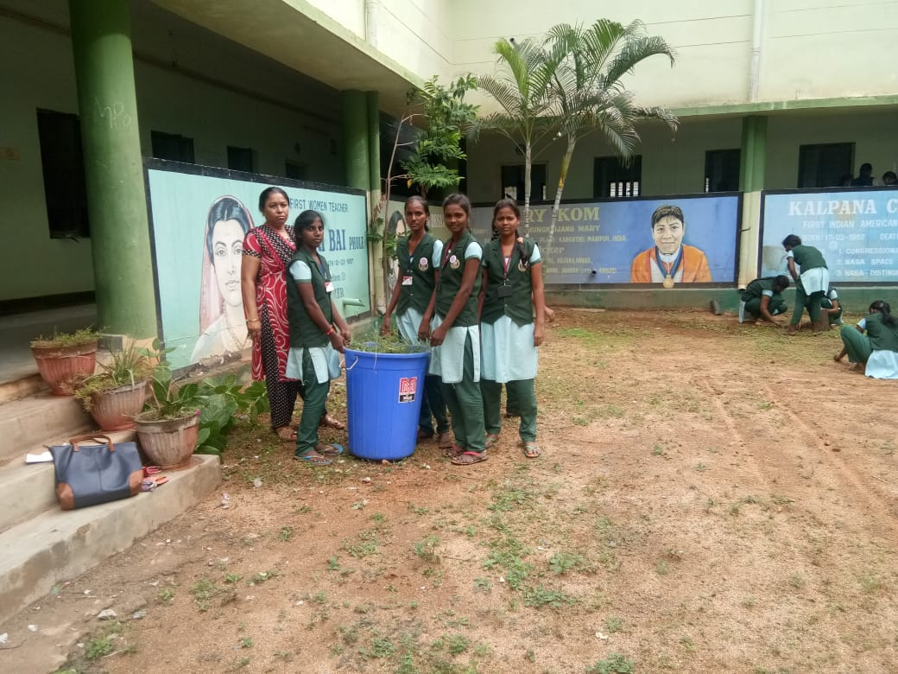

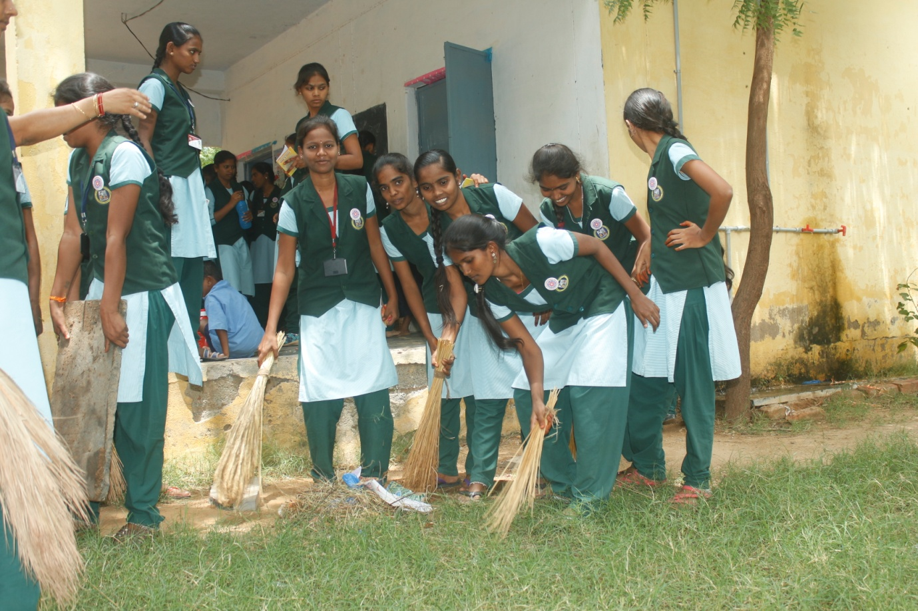

**CELEBRATION OF INTERNATIONAL WOMENS’ DAY ON 8/3/3019**

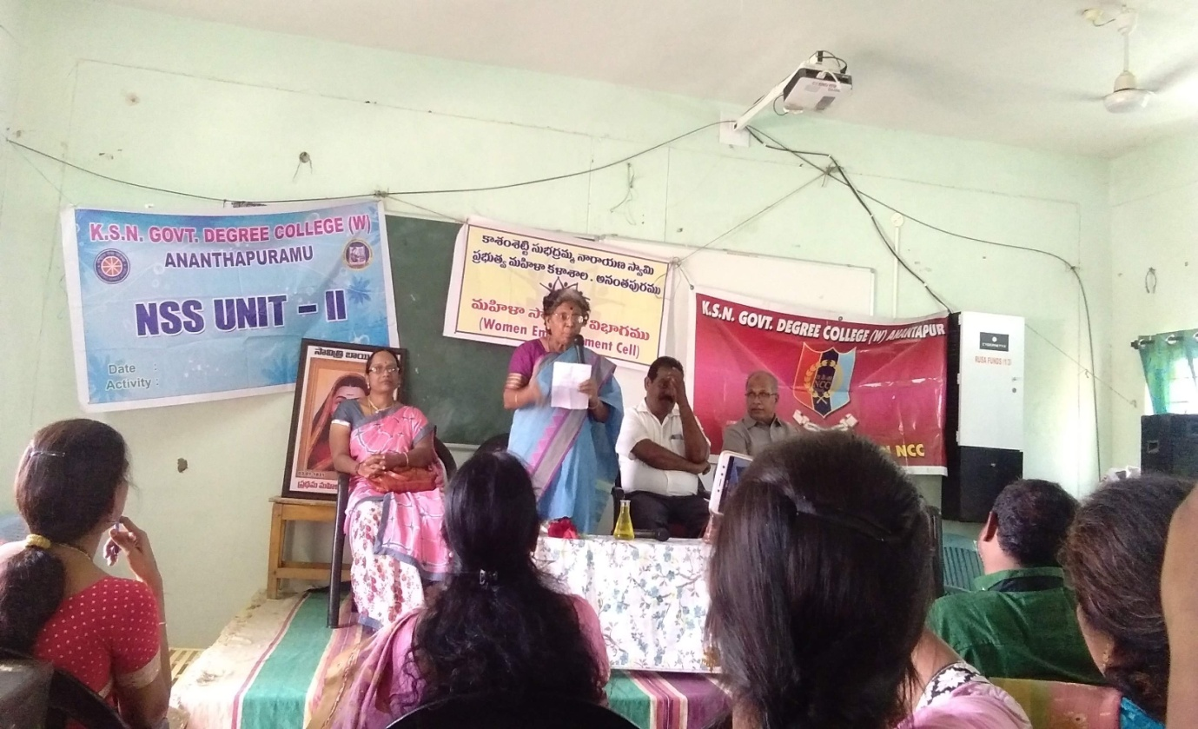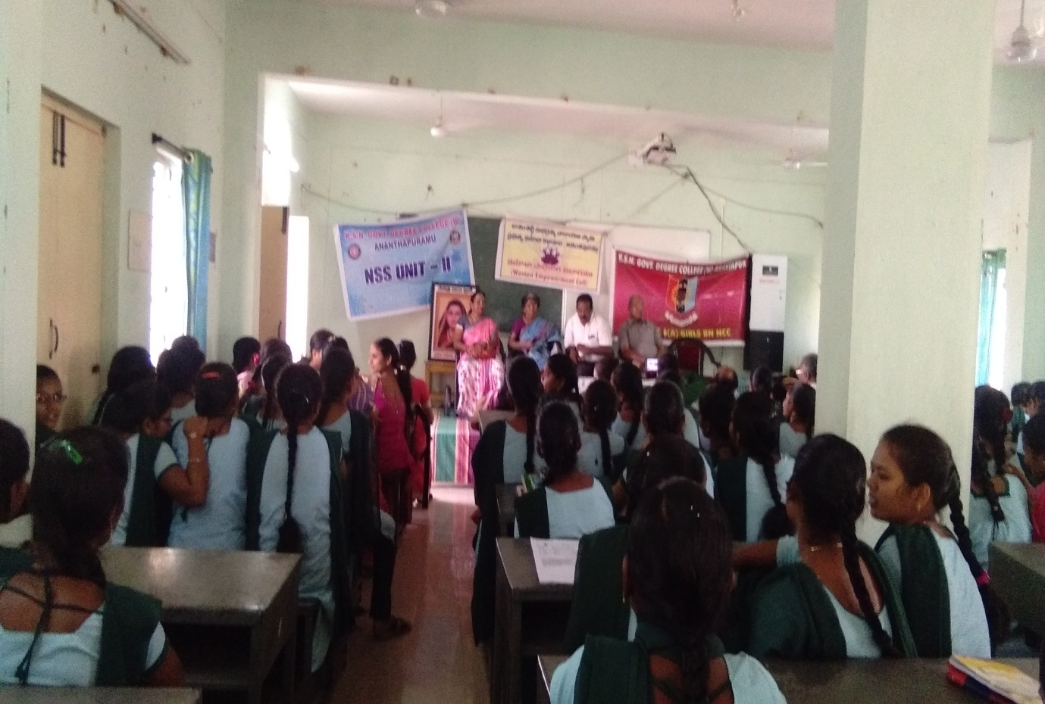

**CONDUCTED AWARENESS PROGRAMME ON PERSONAL HYGIENE TO NSS VOLUNTEERS ON 18/3/2019 BY Dr. Firdous khanam**

